**PROJECT REPORT**

**1. INTRODECTION**

**1.1 Overview**

With the help of Zohobooks of accounts we created profit and loss account and balance sheet and GST(18%) calculate for the Travel trax tours.

**1.2. Purpose**

It is created for the purpose of prepare profit & loss Accounts, balance sheet and prepare GST report for Travel trax tours.

**Preparation and maintainence of zoho Books for** Traveltrax tour

TravelTrax Tours, a tour operator, leverages Zoho Books to manage their bookings, track expenses, and handle invoicing for their customers. They can generate professional invoices, reconcile payments, and monitor their financial performance.

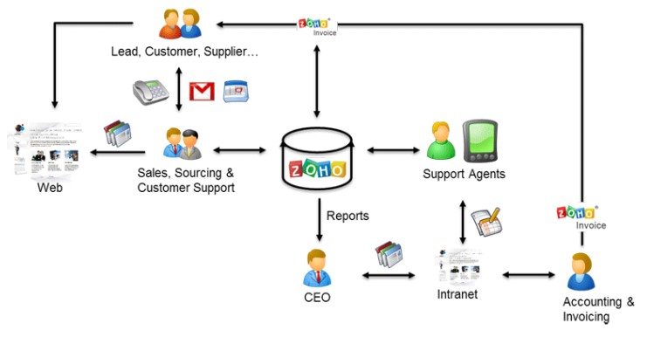

**PROBLEM DEFINITION & DESIGN THINKING**

It is created method of preparation of Accounting profit and loss account, balance Sheet and GST calculation is complicated.

In recent day’s new technologies allotted. Here we use Zohobook as a tool for creating Profit and loss account, balance sheet and GST report.

2.1 Empathy Map

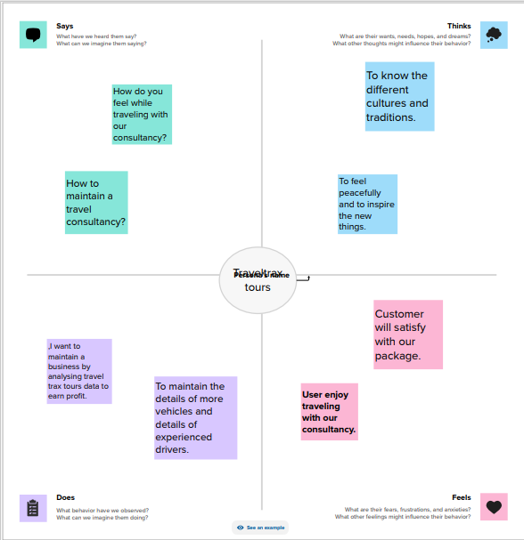

+2.2 Idention & Brainstorming Map

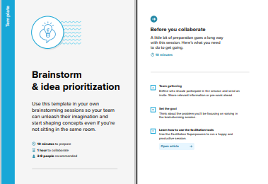

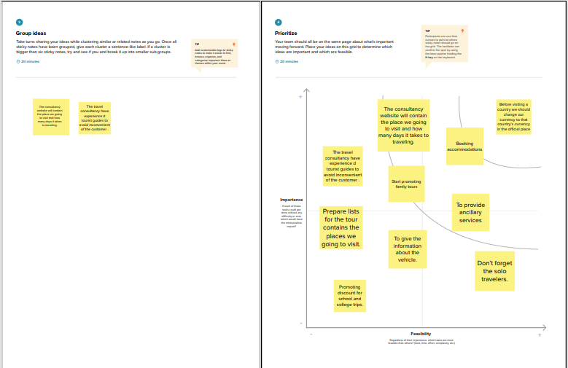

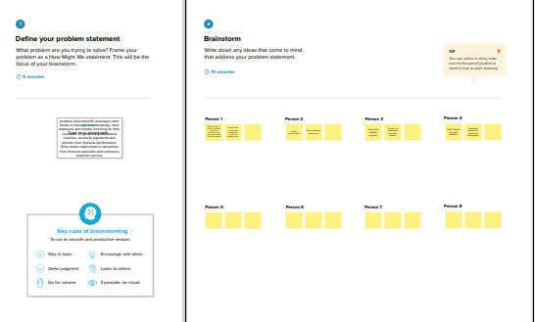

RESULT

Output:

1. Company Name Creation: We have to create a Company Name And other Details From Below Zohobooks

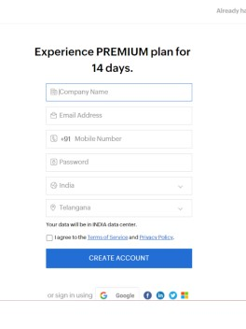

1. **Item Creation:**

We have to create items, Such as

* Item names
* Units
* HSN/SAC
* Selling info/Purchase info
* Tax Rate

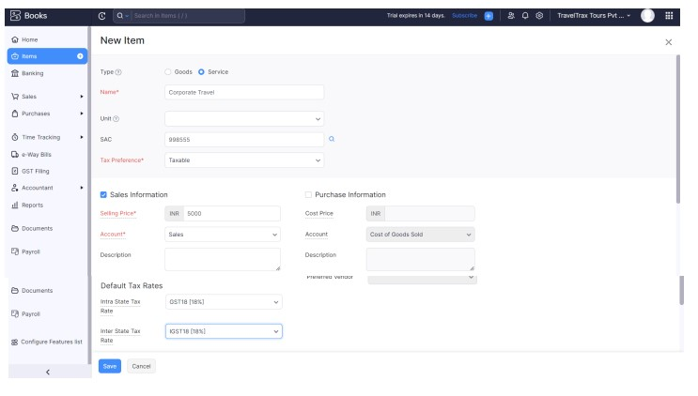

1. **Purchase Order:**

We are creating new purchase order such as below

* Fixture and Furniture

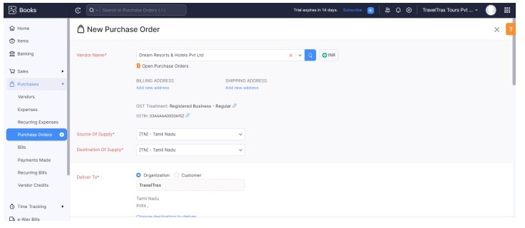

1. **Sales Order**:

Travel trax tours received below sales order from mentioned customer

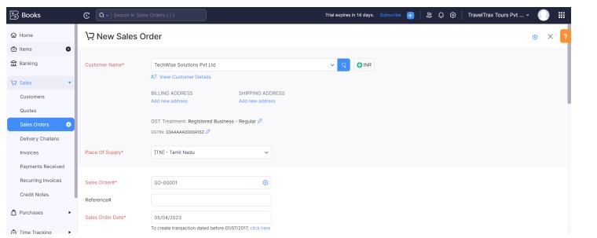

1. **Profit and loss Account\ Balance Sheet\GST Report:**

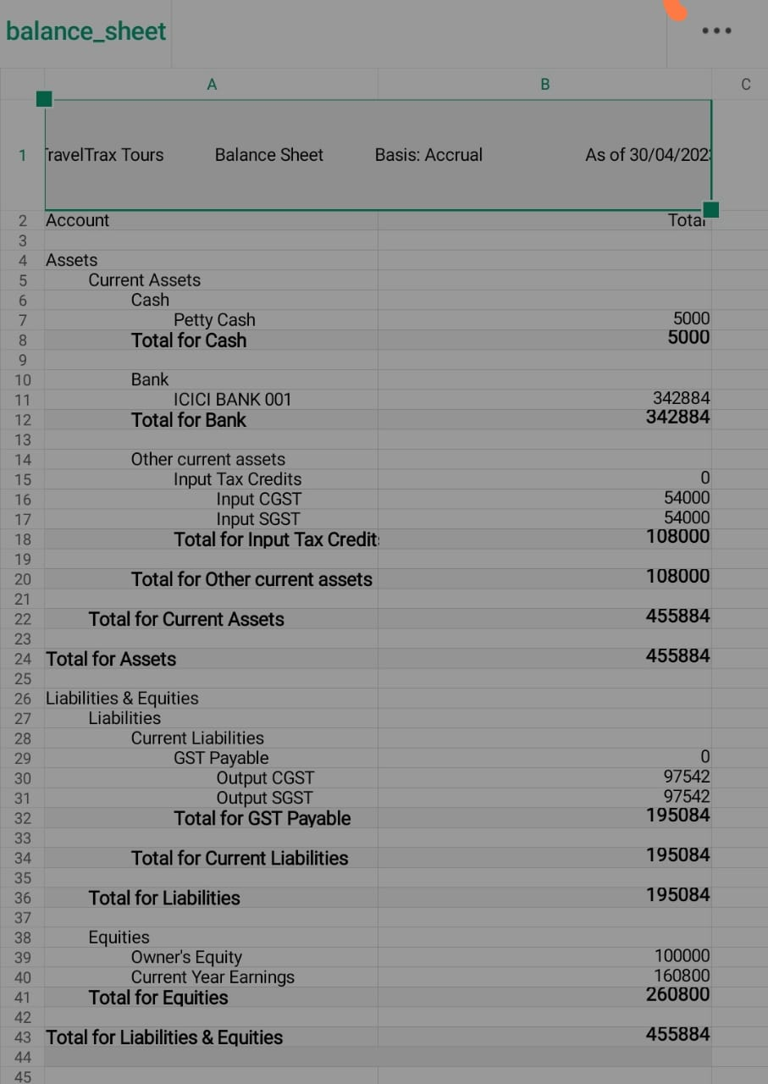

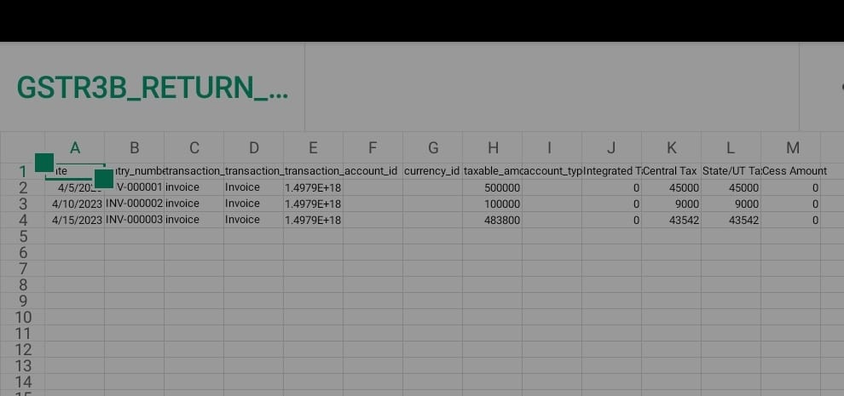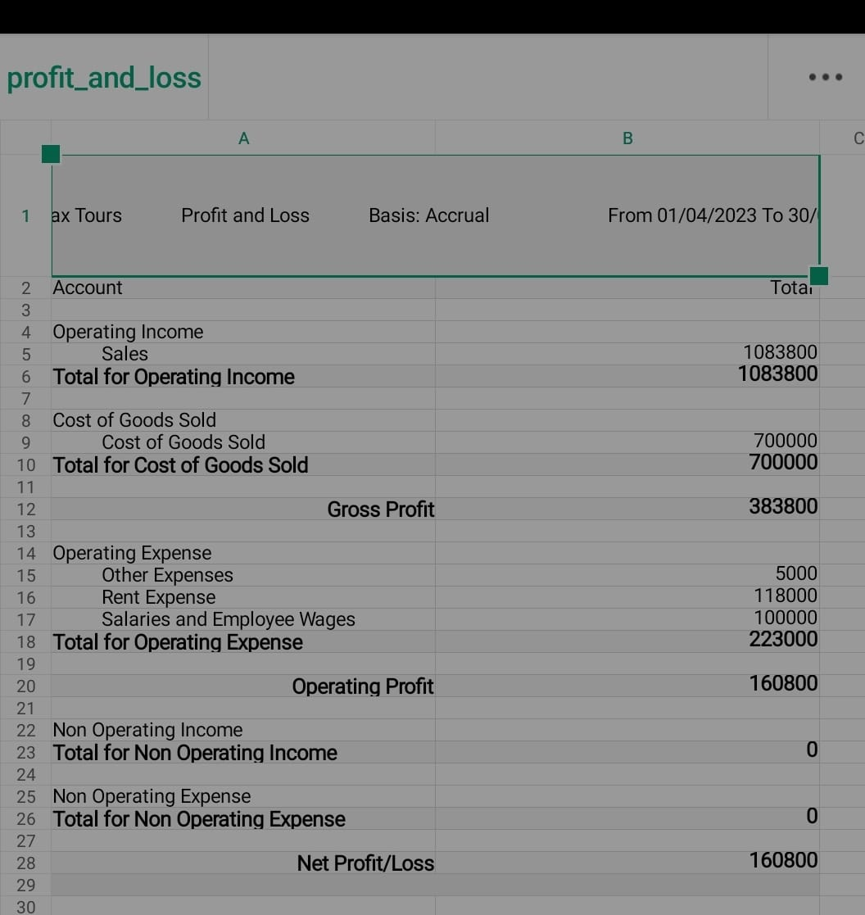

* **ADVANTAGE & DISADANTAGE:**

ADVANTAGE: Good Interior and Exterior

DISADVANTAGE: Missing New Version

* **APPLICATION:**

This application used to maintain the company details and ledger accounts, profit and loss Account and Balance sheet of the company of Travel trax tours.

* **CONCLUSION:**

Travel trax tours from features converge. By implementing well conceived designs of principles, communities are functioned.

* **FUTURE SCOPE:**

In upcoming year digitalization is the future. Most of the companies are computerized for many reasons. Maintaining accounts are also computerized in future. With these new Technology preparation of company details. Accounting software was user friendly Ant it can be adopted.

* **APPENDIX:**

Approved development

Future Assessment

Plan of development

Development Purpose

Interpretation